Press release

Karl Schmidt-Rottluff (1884 – 1976)

Panel discussion „Karl Schmidt-Rottluff – Artist. Collector. Benefactor.“

Galerie Schüller in the Bayerischer Hof
On Sunday, 30 September, Galerie Schüller invited guests to the opening matinee in the Bayerischer Hof with a panel discussion as part of the exhibition "KARL SCHMIDT-ROTTLUFF. Two masterpieces - one wooden plaque. " Tanja Pirsig-Marshall (Deputy Director LWL Museum für Kunst und Kultur, Münster) and Christiane Remm (Curator Karl and Emy Schmidt-Rottluff Foundation, Berlin) talked in front of an exclusive audience of approximately 25 guests. The event was moderated by Dr. Sebastian Preuss (Deputy Editor-in-Chief Weltkunst and Kunst und Auktionen, Berlin)

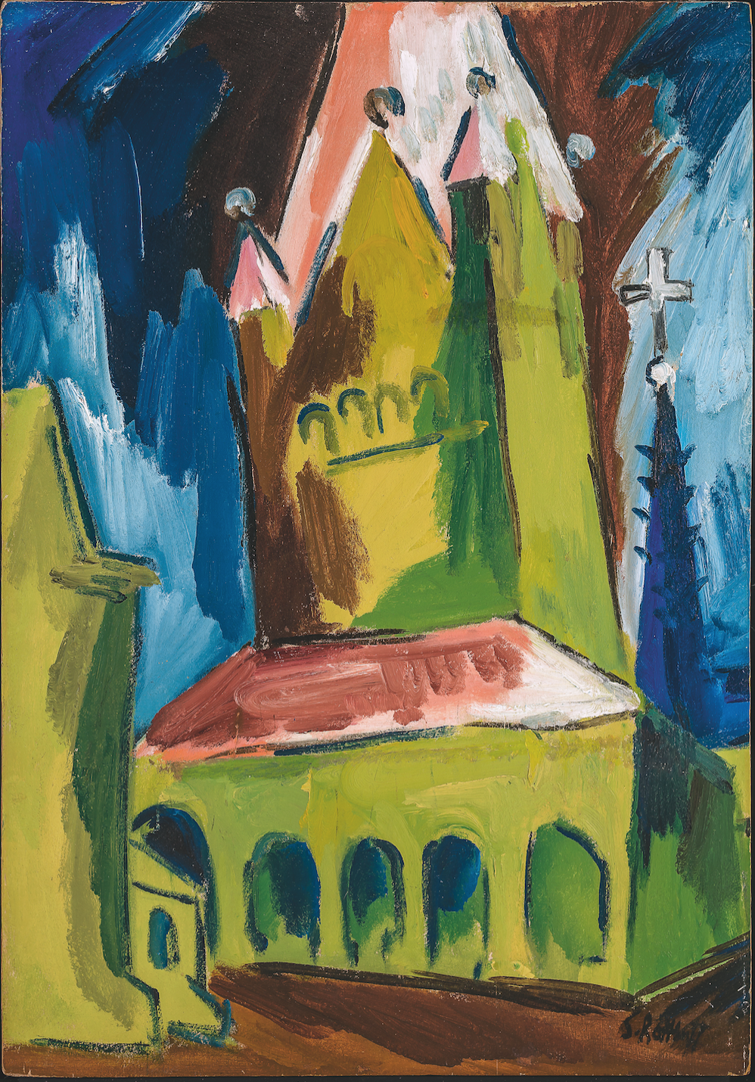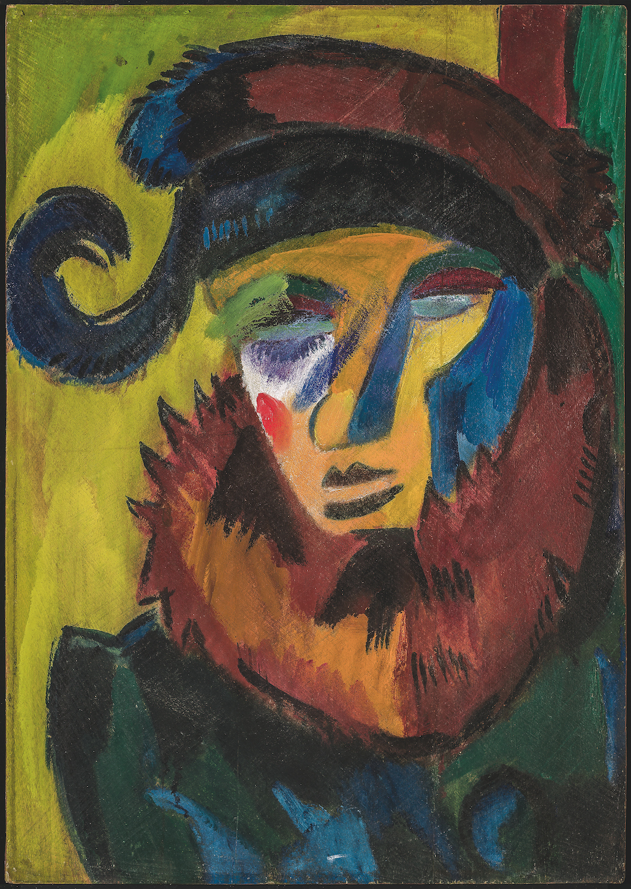

© VG-BILDKUNST, Bonn 2018

After an introduction and an atmospheric Nolde quote presented by Ingrid Pérez de Laborda, art historian of the Galerie Schüller, the lively discussion group started. It was agreed that the pictures Dame mit Hut and Katholische Probsteikirche St. Patrokli, Soest, which are now available for the first time on the art market, are "wonderful and a highlight on the art market" (Preuss). The founding of the artist group Brücke marked the birth of the avant-garde in Germany. This return to raw nature, the spontaneously sketchy, which today belongs to the taste canon of the Classical Modernism, was then a novelty. And the two pictures are the best proof of that and of “exhilarating beauty” (Preuss).
After the speakers described the adverse circumstances of Schmidt-Rottluff and Otto Müller in Berlin after the First World War, the importance of Westphalia as a focal point for the Expressionists was discussed. The Folkwang Museum in Hagen, founded in 1902 by Karl Ernst Osthaus, certainly played an important role. Unusually early, Osthaus collected modern artists (including Henri Matisse) and worked as a patron. He also promoted many German emerging artists such as Christian Rohlfs, by providing workspaces in the Folkwang Museum. The museum paved the way for a new generation of artists, creating a progressive climate. It occasionally formed groups of artists, such as Eberhard Viegener, but there were mostly individualists to be found there.
After Schmidt-Rottluff had rejected a professorship at the Bauhaus to devote himself entirely to his art, he traveled again in the 1920s to Westphalia and took a stay in Soest, which still boasts an imposing medieval city center. He produced a series of several paintings, watercolors and woodcuts (among others, the pendant in oil from the LWL Museum für Kunst und Kultur, Münster) of his impression of the monumental compact-cubist tower of St. Patrokli Cathedral. Mrs. Remm is of the opinion that the luminous pictures were probably painted not in front of the motif, but in the studio, which could explain the clear degree of abstraction. Perhaps a postcard of the sacral building may have served as a reminder.
Next, the exquisite round discussed the fact that the two panels were originally a wooden panel, which the collector Franz Zöllner had carefully separated in 1979. It is not uncommon, according to the curator of the Schmidt-Rottluff Foundation, to come across double-sided painted canvases in the artist's oeuvre. Schmidt-Rottluff was probably a thoroughly economical man, since this practice was not stopped in the 1950s, when he was already an established artist and it was better ordered to its economic situation. Most of the backs contain only colored sketches, but not a complete composition like the Dame mit Hut. When having a look at the picture, the mask-like face immediately catches the eye. In fact, it has been proven that since 1913 the artist has amassed an extensive collection of African masks, pipe bowls and man-high signs. These objects he probably acquired from the grocery store in the immediate vicinity of his Hamburg studio or got them as souvenirs from Erich Heckel's brother, who was stationed on the African continent for a long time. Until Schmidt-Rottluff's death in 1976, the style of indigenous artifacts had a major impact on his work.
Then the podium guests continued discussing the role of Schmidt-Rottluff within the Brücke. The artist was a founding member of the artist community and at the beginning was still very enthusiastic. Over the years he yearned to be at rest for work and increasingly estranged himself from the common ideals. Later he saw the Brücke more and more as an exhibition community in the practical sense. Mrs. Dr. Pirsig-Marshall and Mrs. Remm discussed the challenges of provenance research in their work for the LWL Museum and the Karl and Emy Schmidt-Rottluff Foundation.
Finally, Mrs. Pérez de Laborda introduced the hitherto unknown collector Franz Zöllner. He came from an old family of musicians and was himself a cellist in the Hagen Orchestra. His love of art was inflamed in his youth when he was able to see from the classroom in Rohlfs’s studio. Little by little, he built up friendly relations with the prominent artist personalities of his time, ia. to Emil Nolde, who gave him a second cloud watercolor as a replacement for the 1947 stolen painting from a Nolde retrospective in the Osthaus Museum. Later Zöllner came in contact with Karl Schmidt-Rottluff, from which he bought several works, including in 1965 the double-sided oil painting.
We would like to thank the podium guests for the stimulating discussion. Accompanying the exhibition, a publication was released in which the participants of the panel discussion recorded their findings in articles. It is available in the gallery or online under http://www.galerie-schueller.de/de/ausstellungen.html.
The special exhibition "Two Masterpieces - one wooden plaque" can be seen at Galerie Schüller until December 31, 2018. The opening hours of the gallery are: Monday - Friday from 11-19 o’clock and Saturday from 11-16 o’clock. Please make an appointment if you want to stop by outside our opening hours.
Link: https://www.galerie-schueller.de/de/presse-ksr-pd.html

